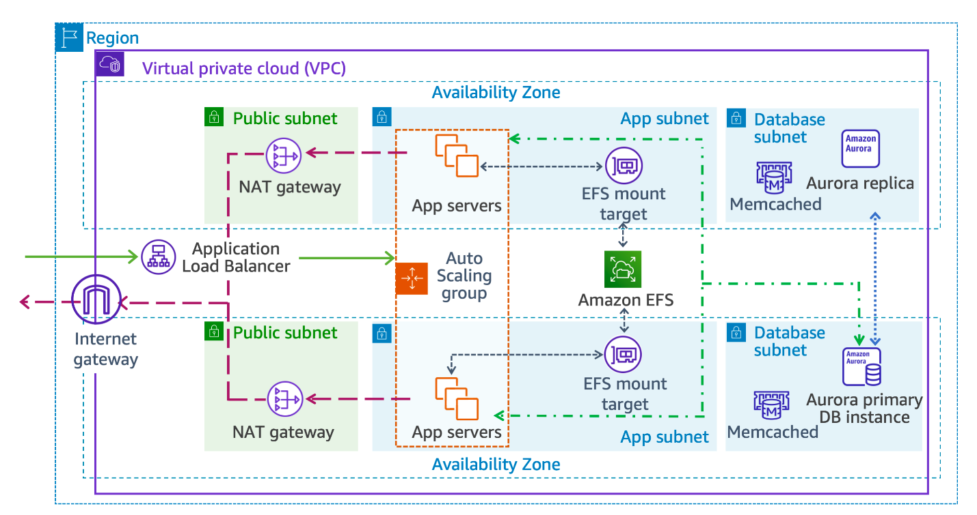

AWS Well-Architected Framework Analysis
Operational Excellence
OPS 4: How do you implement observability in your workload?
This architecture supports observability through AWS CloudWatch metrics, logs, and alarms. The Application Load Balancer, Auto Scaling group, and Aurora database all integrate with CloudWatch, enabling monitoring of traffic patterns, server health, and query performance. To strengthen observability, structured logging and distributed tracing (using AWS X-Ray) can be added to track requests across services. Dashboards can provide visibility into KPIs such as latency, error rates, and scaling events, ensuring proactive detection of issues.
OPS 6: How do you mitigate deployment risks?
Deployment risks are mitigated by using Auto Scaling groups and multiple Availability Zones, which ensure workloads remain available even if one zone fails. Blue/green or canary deployments via AWS CodeDeploy or CodePipeline can further reduce risk by gradually rolling out changes and allowing rollback if issues arise. Infrastructure as Code (IaC) with AWS CloudFormation ensures consistent, repeatable deployments, minimizing human error.

Security
SEC 3: How do you manage permissions for people and machines?
Permissions are managed through AWS Identity and Access Management (IAM). IAM roles are assigned to EC2 instances and Lambda functions to grant least-privilege access to resources like EFS or Aurora. Human users authenticate with IAM users or federated identities, using MFA for added security. Policies enforce separation of duties, ensuring administrators, developers, and auditors have distinct access scopes.
SEC 4: How do you detect and investigate security events?
AWS CloudTrail logs all API calls, enabling detection of unusual activity. GuardDuty provides continuous threat detection, while AWS Config tracks configuration changes. Security Hub aggregates findings across services. When an event occurs, logs from CloudTrail and VPC Flow Logs can be analyzed to identify root causes, and automated responses can be triggered with AWS Lambda to isolate compromised resources.

Reliability
REL 7: How do you design your workload to adapt to changes in demand?
The architecture uses Auto Scaling groups behind an Application Load Balancer to automatically add or remove EC2 instances based on traffic. Aurora databases scale read replicas to handle increased query loads, while Memcached provides caching to reduce database pressure. This elasticity ensures the workload adapts seamlessly to demand fluctuations.
REL 13: How do you plan for disaster recovery (DR)?
Disaster recovery is supported by multi-AZ deployments of Aurora and EFS, ensuring data redundancy. Snapshots and backups can be replicated to another region for cross-region DR. Recovery strategies may include pilot-light or warm standby architectures, depending on RTO/RPO requirements. Testing failover scenarios regularly ensures readiness for real incidents.

Performance Efficiency
PERF 1: How do you select appropriate cloud resources and architecture patterns for your workload?
Resources are chosen based on workload needs: EC2 Auto Scaling for compute elasticity, Aurora for high-performance relational databases, and Memcached for caching. The Application Load Balancer distributes traffic efficiently across zones. Using managed services reduces operational overhead and ensures scalability. Architecture patterns like multi-AZ deployment and stateless app servers improve performance and resilience.
PERF 5: What process do you use to support more performance efficiency for your workload?
Performance efficiency is supported by continuous monitoring with CloudWatch and tuning based on metrics. For example, adjusting Auto Scaling thresholds, optimizing Aurora queries, and right-sizing EC2 instances. Regular load testing helps identify bottlenecks. Using caching layers and content delivery networks (CloudFront) can further improve response times.

Cost Optimization
COST 3: How do you monitor usage and cost?
AWS Cost Explorer and Budgets track usage and spending. CloudWatch metrics can be tied to cost drivers, such as EC2 instance hours or database queries. Tagging resources allows cost allocation by project or team. Alerts can notify when spending exceeds thresholds, enabling proactive cost management.
COST 9: How do you manage demand, and supply resources?
Demand is managed through Auto Scaling, which supplies resources only when needed. Aurora’s serverless option can scale database capacity automatically. Spot Instances can be used for non-critical workloads to reduce costs. By matching supply to demand dynamically, the architecture avoids over-provisioning and minimizes waste.

Sustainability
SUS 3: How do you take advantage of software and architecture patterns to support your sustainability goals?
Stateless application servers and Auto Scaling reduce idle resources, lowering energy consumption. Caching with Memcached reduces database load, improving efficiency. Using managed services like Aurora and EFS ensures workloads run on optimized infrastructure maintained by AWS, which is more energy-efficient than self-managed hardware.
SUS 5: How do you select and use cloud hardware and services in your architecture to support your sustainability goals?
Choosing AWS managed services leverages AWS’s commitment to renewable energy and efficient data centers. Right-sizing EC2 instances and using serverless options (Aurora Serverless, Lambda) minimize unnecessary hardware usage. Multi-AZ deployments ensure resilience without excessive duplication, balancing sustainability with reliability.

